**Ring Toss**

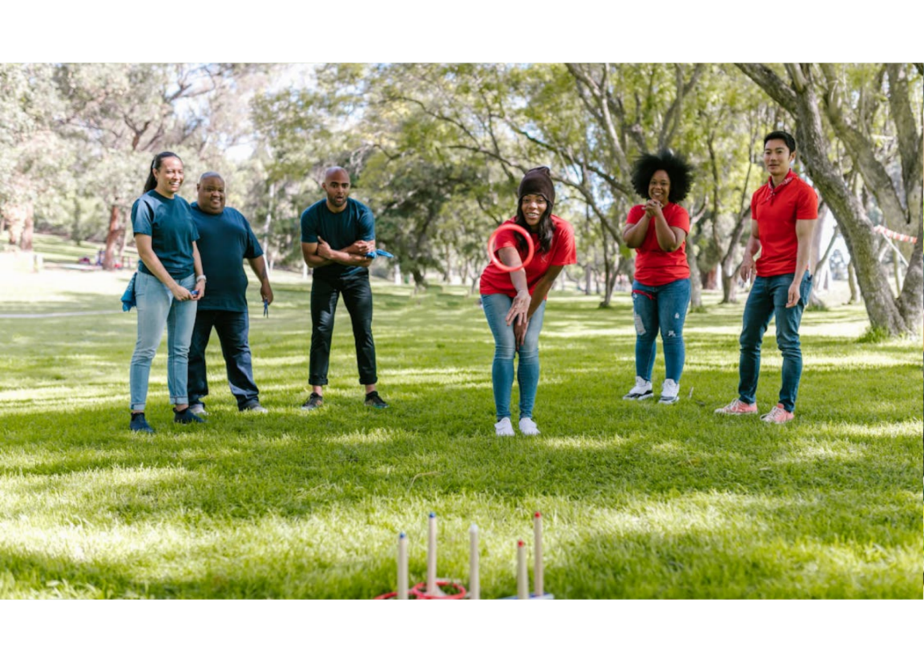

**Description**: Players aim to throw rings onto pegs, scoring points based on accuracy.

**How to Play**: Players take turns throwing rings at pegs. Points are scored based on how many rings land on the pegs.

**Location**: Backyard, park.

**Things Needed**: Rings, pegs.

**Players**: 2 or more.